**CSC 482**

**Assignment 2**

**Go Polling Worker and Loggly**

**Github Repository**: <https://github.com/pnguyen3oswego/csc482>

**Screenshot of output console:**

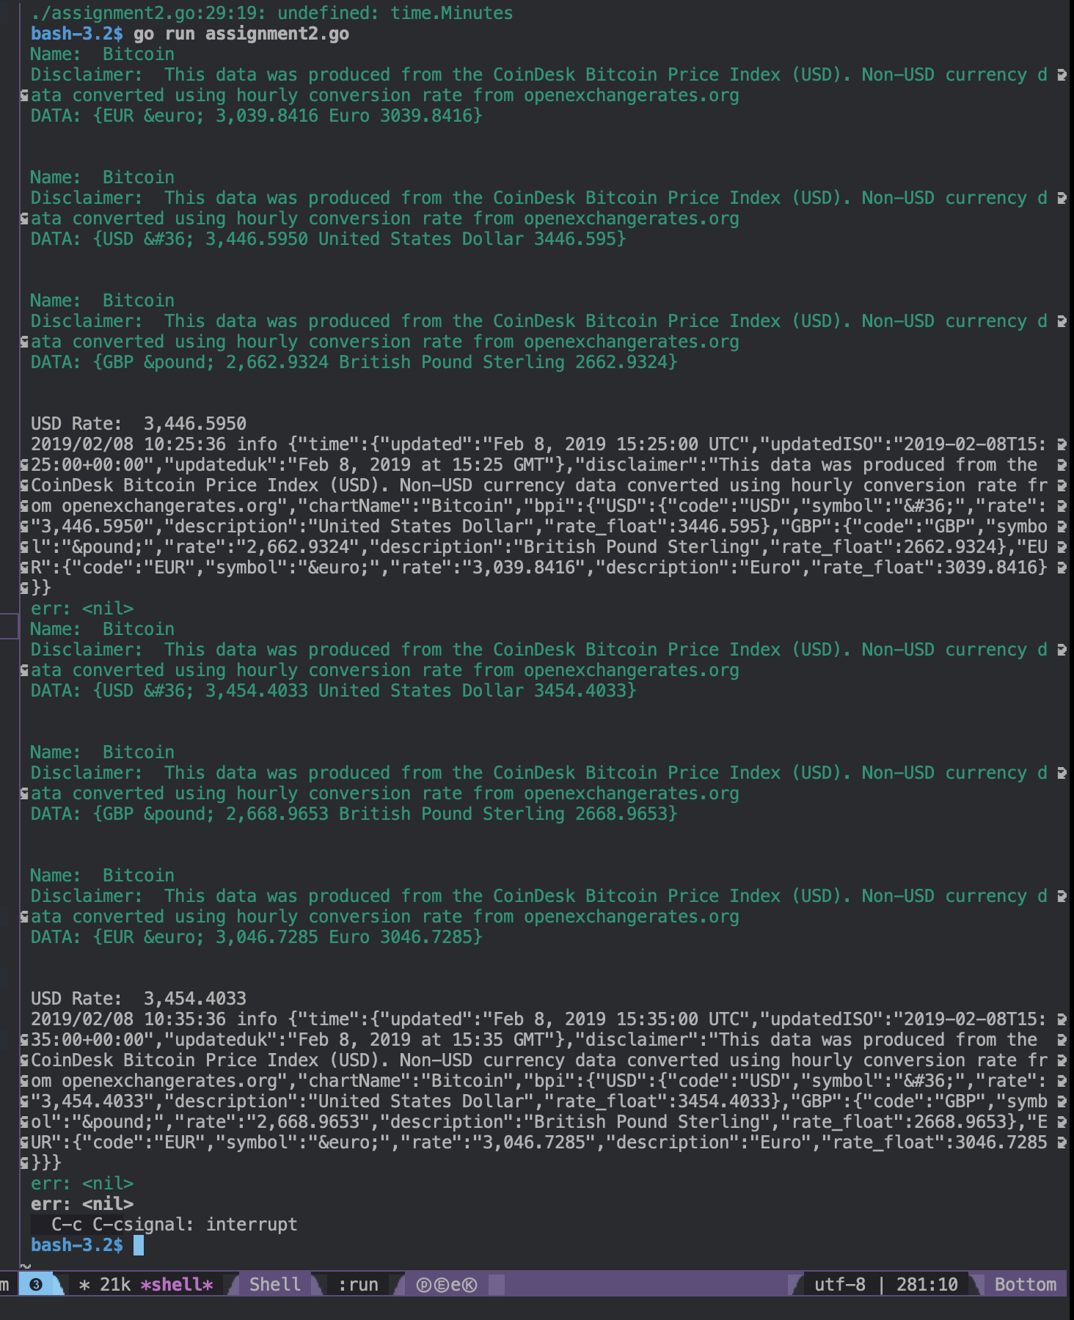

**Screenshot of Loggly:**

